Day 26 — Real-Time Healthcare Project

Create build.sbt:
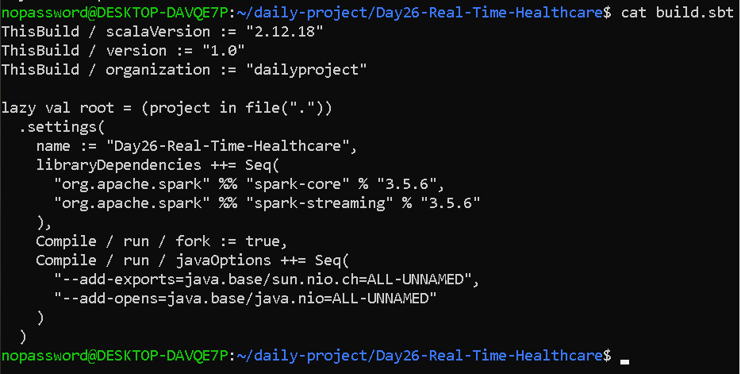

Create the program:
cat > HealthcareMonitoring.scala <<'EOF'
import org.apache.spark.SparkConf
import org.apache.spark.streaming._
import org.apache.spark.rdd.RDD

import scala.collection.mutable

// Patient-vital event schema
case class VitalEvent(
patientId: String,
eventTime: String,
heartRate: Double,
spo2: Double,
temperature: Double,
systolicBP: Int
)

// Configurable example thresholds for this learning project
case class VitalThresholds(
minHeartRate: Double = 60.0,
maxHeartRate: Double = 100.0,
minSpO2: Double = 95.0,
maxTemperature: Double = 38.0,
maxSystolicBP: Int = 140
)

object HealthcareMonitoring {

def main(args: Array[String]): Unit = {

val conf = new SparkConf()
.setAppName("Day26-Real-Time-Healthcare")
.setMaster("local[2]")

val ssc = new StreamingContext(conf, Seconds(2))
ssc.sparkContext.setLogLevel("ERROR")
ssc.checkpoint("./checkpoint")

// Broadcast threshold settings to Spark tasks
val thresholds =
ssc.sparkContext.broadcast(VitalThresholds())

// Counts abnormal events processed by Spark tasks
val abnormalCounter =
ssc.sparkContext.longAccumulator("AbnormalVitalReadings")

// Sample readings, one batch every 2 seconds
val batches = Seq(
Seq(
VitalEvent("P101", "10:00:00", 75, 98, 36.8, 120),
VitalEvent("P102", "10:00:00", 125, 89, 37.0, 130)
),
Seq(
VitalEvent("P101", "10:00:02", 78, 98, 36.9, 122),
VitalEvent("P102", "10:00:02", 130, 90, 37.1, 132)
),
Seq(
VitalEvent("P101", "10:00:04", 80, 97, 36.8, 125),
VitalEvent("P102", "10:00:04", 128, 91, 37.2, 135)
),
Seq(
VitalEvent("P101", "10:00:06", 115, 94, 38.5, 145),
VitalEvent("P102", "10:00:06", 82, 98, 36.8, 125)
),
Seq(
VitalEvent("P101", "10:00:08", 120, 92, 38.7, 150),
VitalEvent("P102", "10:00:08", 85, 97, 36.9, 128)
),
Seq(
VitalEvent("P101", "10:00:10", 122, 91, 38.8, 152),
VitalEvent("P102", "10:00:10", 80, 98, 36.8, 126)
),
Seq(
VitalEvent("P101", "10:00:12", 82, 98, 36.9, 124),
VitalEvent("P102", "10:00:12", 118, 93, 38.2, 145)
),
Seq(
VitalEvent("P101", "10:00:14", 79, 98, 36.8, 122),
VitalEvent("P102", "10:00:14", 121, 92, 38.4, 148)
)
)

val queue = mutable.Queue[RDD[VitalEvent]]()

batches.foreach { batch =>
queue.enqueue(ssc.sparkContext.parallelize(batch))
}

val patientStream = ssc.queueStream(queue, oneAtATime = true)

// Check vital readings against broadcast thresholds
val checkedReadings = patientStream.map { event =>
val t = thresholds.value

val reasons = Seq(
if (event.heartRate < t.minHeartRate ||
event.heartRate > t.maxHeartRate)
Some("Abnormal heart rate") else None,

if (event.spo2 < t.minSpO2)
Some("Low SpO2") else None,

if (event.temperature > t.maxTemperature)
Some("High temperature") else None,

if (event.systolicBP > t.maxSystolicBP)
Some("High systolic blood pressure") else None
).flatten

val abnormal = reasons.nonEmpty

if (abnormal) {
abnormalCounter.add(1L)
}

(event, abnormal, reasons.mkString(", "))
}

// Print readings and abnormal-vital alerts
checkedReadings.foreachRDD { rdd =>
rdd.collect().foreach { case (event, abnormal, reasons) =>
println(
s"[VITAL] Patient=${event.patientId}, " +
s"HR=${event.heartRate}, SpO2=${event.spo2}, " +
s"Temp=${event.temperature}, BP=${event.systolicBP}"
)

if (abnormal) {
println(
s"[ALERT] Patient ${event.patientId}: $reasons"
)
}
}
}

// Count abnormal events in the most recent 10-second window.
// Short window used for this demonstration.
val abnormalOnly = checkedReadings.filter(_._2)

val abnormalWindowCount =
abnormalOnly.countByWindow(Seconds(10), Seconds(4))

abnormalWindowCount.foreachRDD { rdd =>
rdd.collect().foreach { count =>
println(s"[WINDOW] Abnormal readings in window: $count")
}
}

// Track consecutive abnormal readings for each patient.
// A normal reading resets the patient's count to zero.
val patientAbnormalState = checkedReadings
.map { case (event, abnormal, _) =>
(event.patientId, abnormal)
}
.updateStateByKey[Int](
(values: Seq[Boolean], previous: Option[Int]) => {
val startingCount = previous.getOrElse(0)

val newCount = values.foldLeft(startingCount) {
(count, abnormal) =>
if (abnormal) count + 1 else 0
}

Some(newCount)
}
)

patientAbnormalState.foreachRDD { rdd =>
rdd.collect().foreach { case (patientId, count) =>
println(
s"[STATE] Patient=$patientId, consecutive abnormal readings=$count"
)

if (count >= 2) {
println(
s"[REPEATED ALERT] Patient $patientId has repeated abnormal readings"
)
}
}
}

println("Starting Real-Time Healthcare Monitoring...")
println("Batch interval: 2 seconds")
println("Demonstration window: 10 seconds")
println("Sliding interval: 4 seconds")

ssc.start()
ssc.awaitTerminationOrTimeout(35000)
ssc.stop(stopSparkContext = true, stopGracefully = true)

println(
s"[SUMMARY] Abnormal readings processed: ${abnormalCounter.value}"
)
}
}
EOF

OUTPUT—

